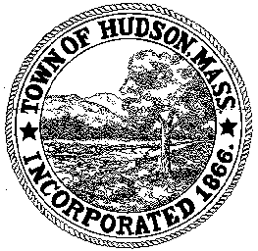

CONSERVATION COMMISSION
78 Main Street, Hudson, MA 01749
(978) 562-2020

Paul Byrne, Chairman W. Minot Wood, Vice Chairman David Esteves, Member

Terrence Joyce, Member Leif Longtine, Member Joseph Rodrigues, Member Al Tashian, Member

Meeting Agenda
August 2, 2012 7:00 P.M.

- Preliminaries
  - Open Meeting
  - Roll Call

2.0 New Business
2.1 RDA 430
Applicant: Brian Hache
Location: 42 Harriman Road
Project Description: the removal of 3 trees and the repair of an existing stone wall. An addition to the existing home may take place within the next 3 years.

2.2 RDA 431
Applicant: Linda Ghiloni
Location: Loureira Property/Community Garden
Project Description: the installation of a concrete pad and shed to house gardening supplies, water meter, backflow device and water hook up.

2.3 RDA 432
Applicant: Department of Recreation
Location: 43 Brigham Street
Project Description: Minor grading and reseeding of an existing athletic field.

2.4 DEP 190-0489
Applicant: Jose Matos
Location: 1 Glendale Road
Project Description: construction of an addition to an existing multi-family house, including two new dwelling units, expansion of the driveway and parking area and a new septic system within the Riverfront Area and within the Buffer Zone of Bordering Vegetated Wetlands.

2.4 DEP 190-0561
Applicant: Jack Sargent, Wildwater Development, LLC
Location: 141/153 Broad Street
Project Description: construction of a 34-unit apartment complex and to respond to an Enforcement Order.

2.5 Minutes: June 21, 2012

2.6 Vouche r CC071612 $1,274.26 Outside Consultant
CC071912 $76.25 Office Supplies

3.0 Adjournment

